1. Unfriendly Error message:

Putting characters that is not integer on quantity text box in Adding Moving   
Supplies and pressed next step would result the page below

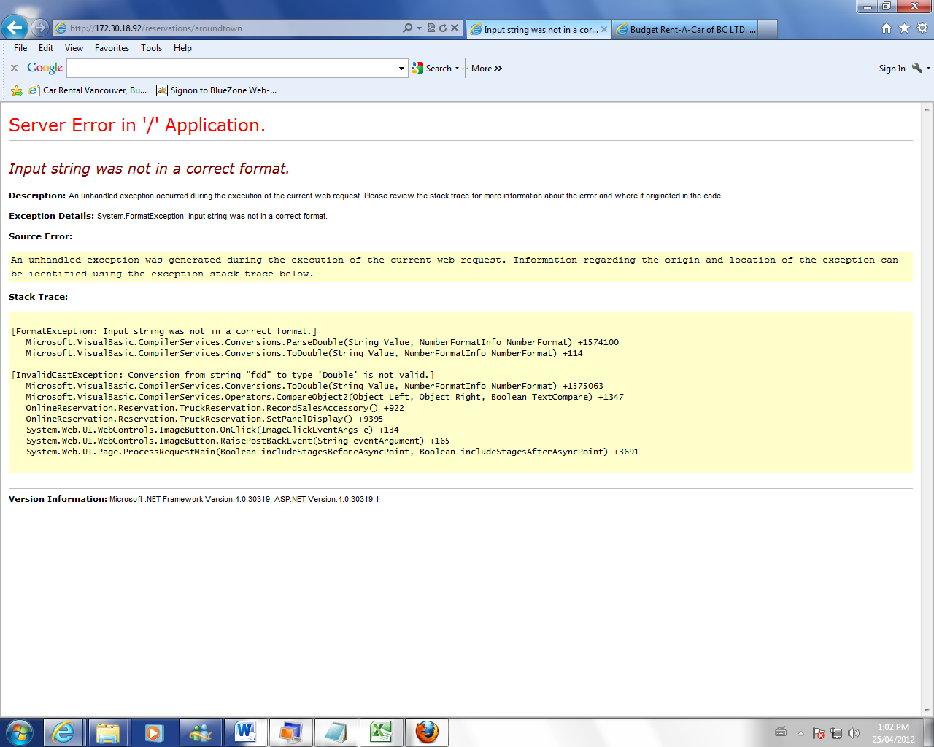

1. Restriction on negative or decimal numbers:

Negative or decimal numbers are allowed on the text box for sale accessory. As a result, there is a negative balance.

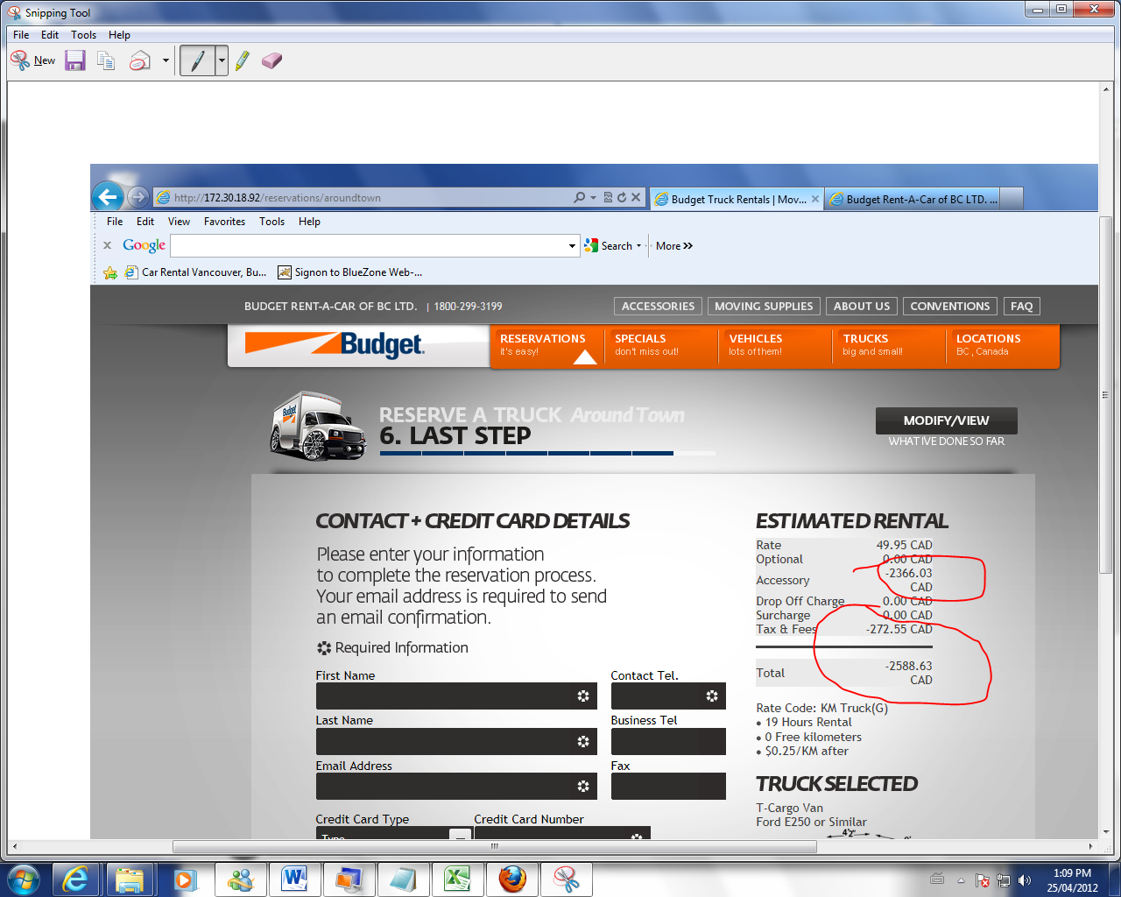

1. Estimated Rental does not display.

The reservation is confirmed. Press modify/view to re-modify then press next step. Credit card number will be asked again .After everything is inserted and next step is pressed. Thank –you message will be prompted but the costs and charges are not listed.

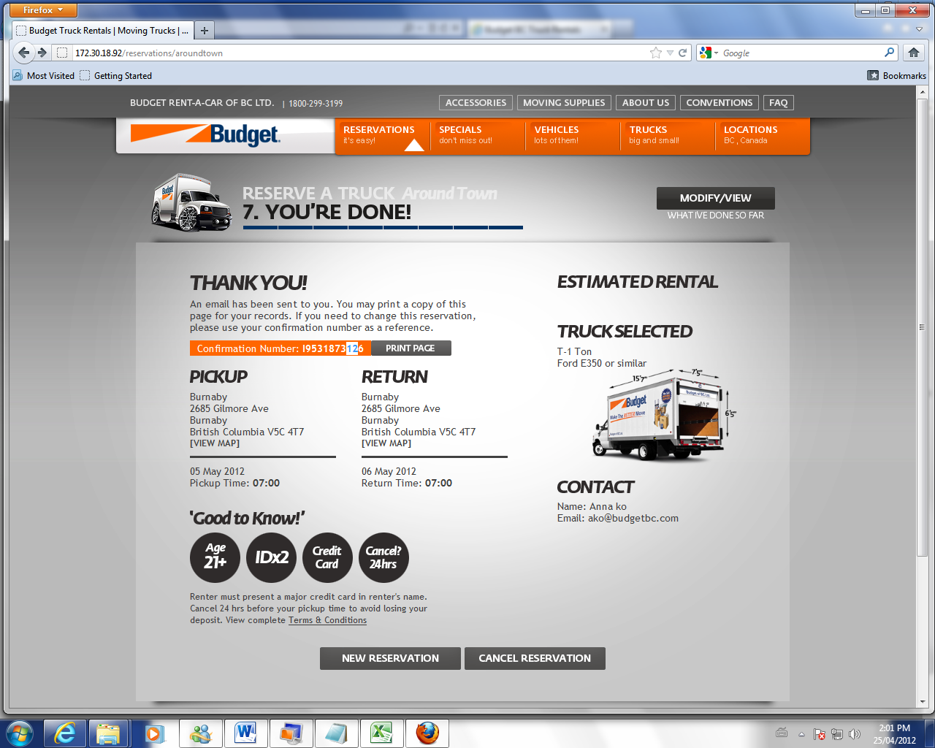

1. Modifying contact-unnecessary request for credit card information

When trying to modify my contact after confirmation is made(for example, I spelled my name wrong and wanted to change it), the program will ask me to input the credit card information again.

1. Cancellation Not working properly

A Reservation is made. Clicks modify/cancel and modify sales accessory. The site will ask you to insert your credit card again. After the insertion, press next step and the cancel reservation will appear on the screen. Press Cancel Reservation and the page below will be displayed. However, there is no confirmation number and the reservation is not cancelled in the GIS

